

**A Mini Project Report on**

“**CUSTOMER BILL PAYMENT SYSTEM OF A RESTAURANT**”

Submitted

In partial fulfilment of the requirement for the III Semester of Bachelor of Technology in CSIT-B during the academic year

2022-23

**Submitted By**

**BHUMIKA.S -- R21EJ069**

**VAISHNAVI A.K -- R21EJ084**

**TANISHA JADHAV -- R21EJ081**

**REVA UNIVERSITY**

School of Computing and Information technology

Bengaluru-560064



**SCHOOL OF COMPUTING & INFORMATION TECHNOLOGY**

This is to certify that the mini project entitled ‘**CUSTOMER BILL PAYMENT SYSTEM OF A RESTAURANT**’ is a Bonafide work carried out by **BHUMIKA.S, VAISHNAVI A.K, TANISHA JADHAV** bearing the SRN’S **R21EJ069, R21EJ084, R21EJ081** respectively in fulfilment of 3rd semester of CSIT-B program of Bachelor of Technology, REVA University during the academic year 2022-23. It is certified that all the corrections/suggestions indicated for internal assessment have been incorporated in the report deposited in the school library. The mini-project report has been approved as it satisfies the academic requirements.

Signature of the Faculty

**(Name of Faculty In-charge)**

**TABLE OF CONTENTS**

**SL. No Chapter Name Page No.**

**1**  **ABSTRACT 4**

**2 INTRODUCTION 5-6**

**3 METHODOLOGY 7-11**

**4 EXPERIMENTAL RESULTS 12-13**

**5 CONCLUSION AND FUTURE WORK 14**

**6 REFERENCES 15**

**ABSTRACT**

The mini project is based on **THE CUSTOMER BILL PAYMENT SYSTEM OF A RESTAURANT**

The customer bill payment system contains the code to develop an application that helps pay any orders made by the customer.

The code mainly focuses on displaying and calculating the amount that has to be paid by the customer for the respective orders that they have placed and also displays any due amount that has to be paid

It contains information about the customer’s account and displays and withdraws the amount to be paid according to the details of the account.

**CONCEPT USED:**

The code mainly uses C programming language and the concept of structures is used to run the code

**SOFTWARE COMPONENTS:**

The code is run on the

* Online C compiler
* Windows Operating System

**HARDWARE COMPONENTS:**

The hardware components are mainly,

* Computer
* Handheld scanner
* Thermal printer
* Cash drawer

**INTRODUCTION**

A **Data Structure** is a [data](https://en.wikipedia.org/wiki/Data) organization, management, and storage format that is usually chosen for [efficient](https://en.wikipedia.org/wiki/Efficiency) [access](https://en.wikipedia.org/wiki/Data_access) to data. More precisely, a data structure is a collection of data values, the relationships among them, and the functions or operations that can be applied to the data.

Data structures are generally based on the ability of a [computer](https://en.wikipedia.org/wiki/Computer) to fetch and store data at any place in its memory, specified by a [pointer](https://en.wikipedia.org/wiki/Pointer_(computer_programming))-a [bit](https://en.wikipedia.org/wiki/Bit) [string](https://en.wikipedia.org/wiki/String_(computer_science)), representing a [memory address](https://en.wikipedia.org/wiki/Memory_address), that can be itself stored in memory and manipulated by the program.

Data Structure is classified into two types:

* **Linear Data Structure**
* **Non-Linear Data Structure**

The program for **‘Customer Bill Payment System of a Restaurant’** is written in **C** programming language and the concepts of **Structures, File Handling Functions** has been used.

**STRUCTURES**

Structure in **C** is a user-defined data type. It is used to bind two or more similar or different data types or data structures together into a single type. Structure is created using the **struct** keyword. A data type created using structure in C can be treated as other primitive data types of C to define a pointer for structure, pass structure as a function argument or a function can have a structure has a return type.

**FILE HANDLING FUNCTIONS**

File handling refers to the method of storing data in the C program in the form of an output or input that might have been generated while running a C program in a data file, i.e., a binary file or a text file for future analysis and reference in that very program.

Some of the file handling functions used in the program are:

* **fopen ():** it is used to create a new file or open an existing file.
* **fclose ():** is used to close a file which was opened.
* **fgetc ():** is used to read the character from the file.
* **fgets ():** is used to read a string from the file.

METHODOLGY

CODE: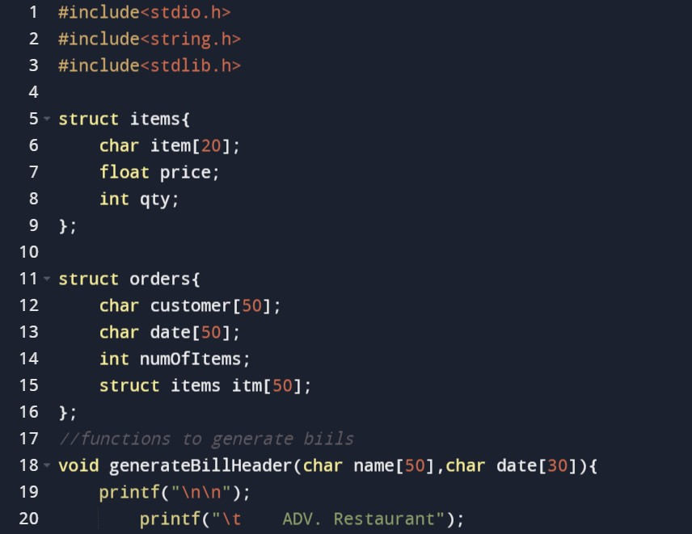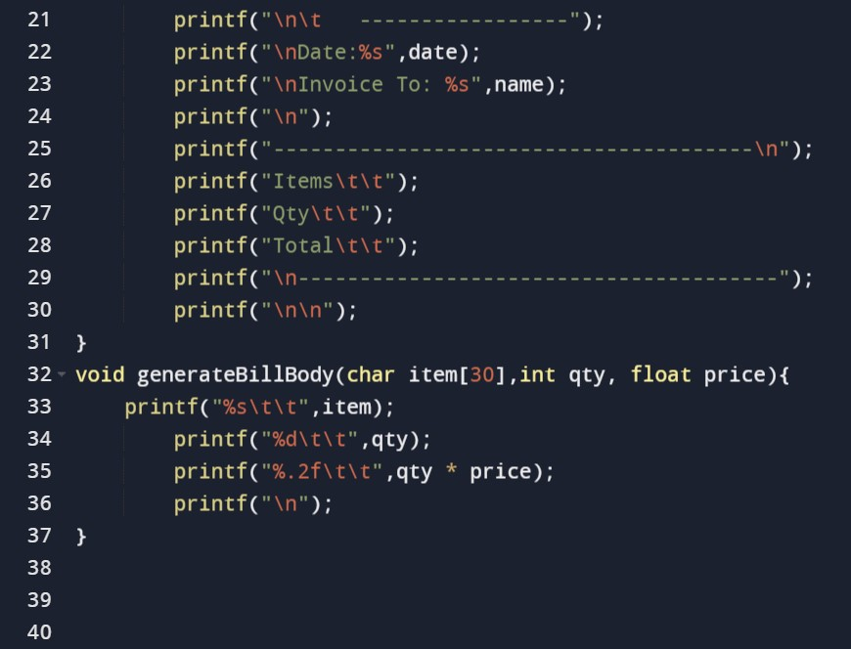

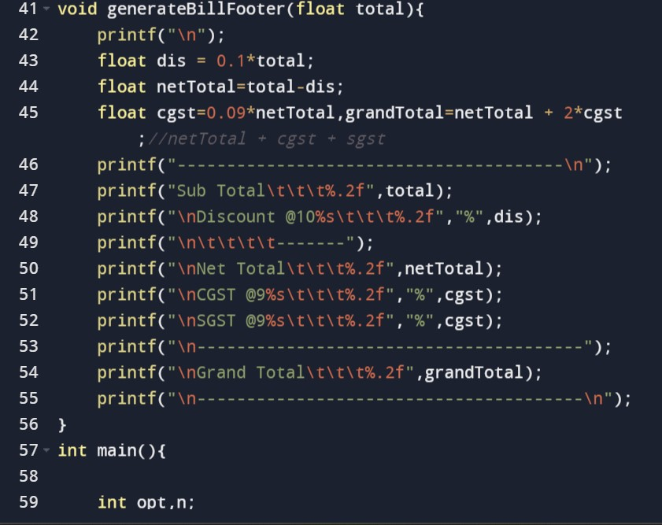

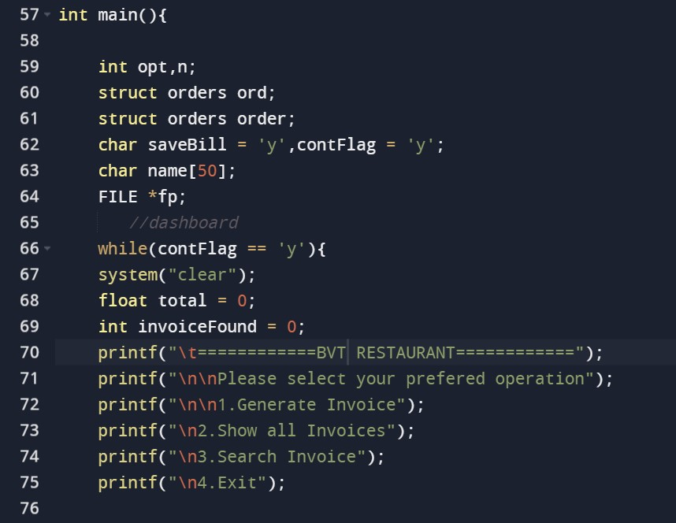

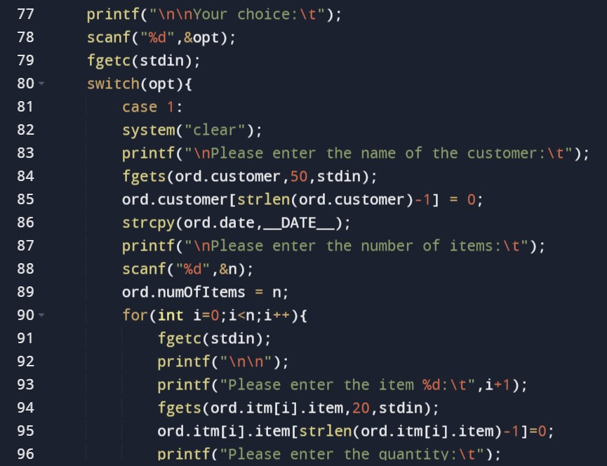

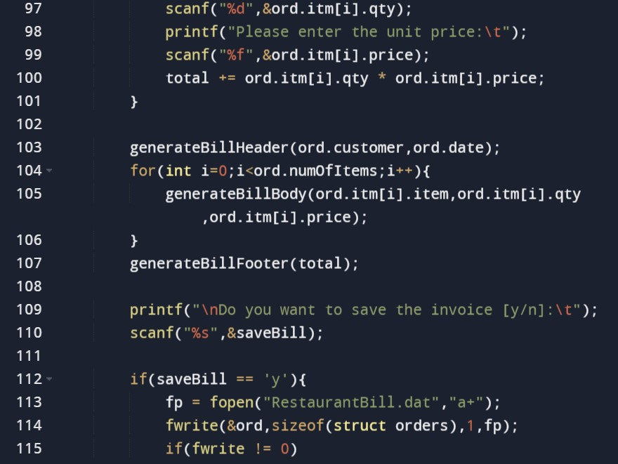

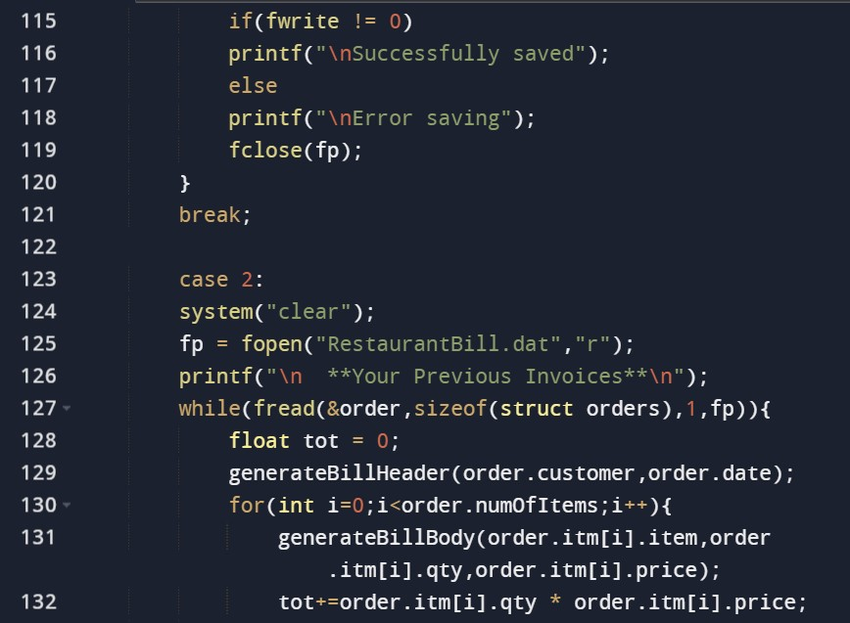

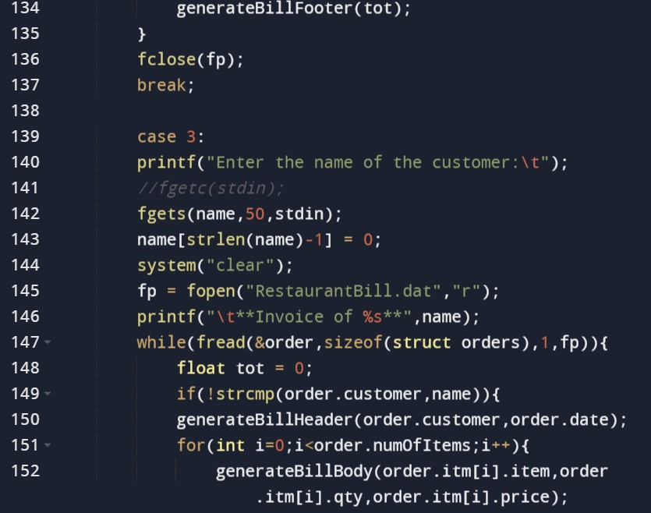

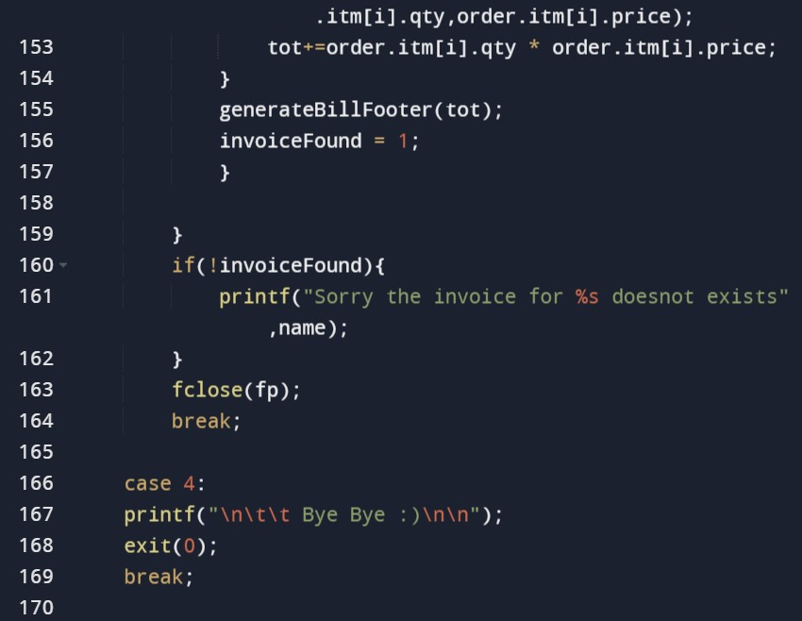

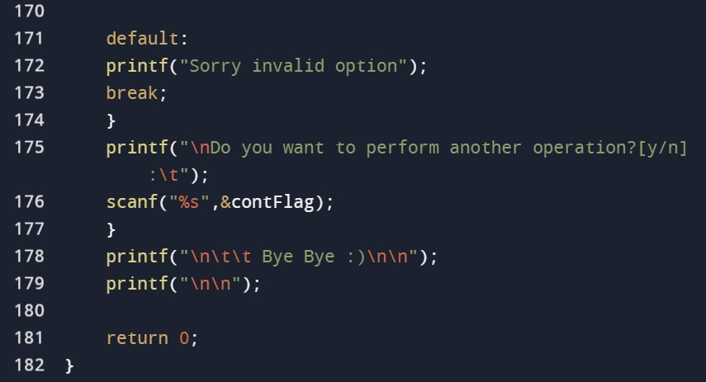

EXPERIMENTAL RESULTS

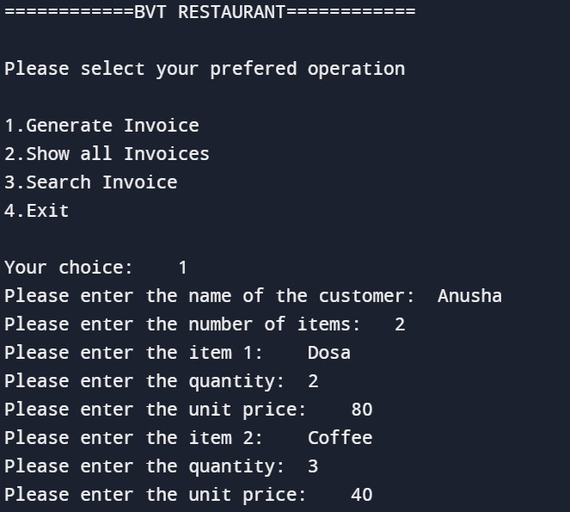

BILL GENERATED:

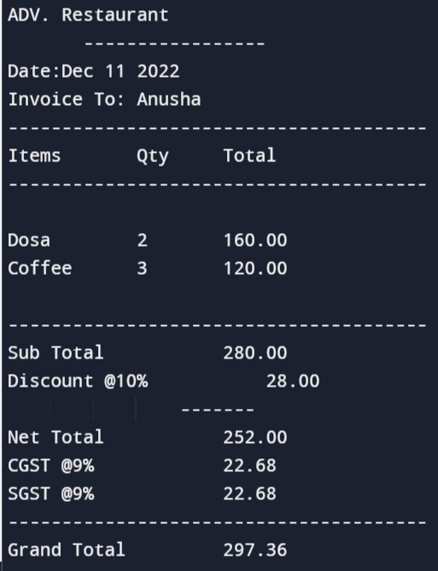

CONCLUSION

The most important aspect of the project was solving and understanding the code in the team. We learned about structures more deeply, which is one of the important concepts used in the code. We learned how to use the struct keyword which is used to store all the basic information, like the item price and quantity and information about the orders of the customer. We have used the void methods to input the price and quantity and also to calculate the bill according to the price and quantity of particular customer. The main function is created to call the methods and print the bill accordingly using the switch case and for loop.

The code has also helped us have a better understanding about the file operations, which are also used in our code

It was important and a challenge for us to learn how to design and modify a program architecture, convert a real-life situation into efficient code, and how we could write readable and understandable code that is both time and memory efficient

Lastly, the project as a whole has helped us build a team spirit and made us understand our strengths in the topic and helped us to manage time efficiently.

FUTURE WORK:

We believe to make a progress using this code by implementing it in real-life situations.

We will try to gather information about the marketing and departmental store needs and try to modify the code accordingly and render it in the future

REFERENCES

The main websites that have helped us with our code on the internet are

* GitHub



* Geeksforgeeks



* Data structures -Wikipedia

